Q1.

CREATE OR REPLACE TRIGGER UpdateCustomerLastModified

BEFORE UPDATE ON Customers

FOR EACH ROW

BEGIN

:NEW.LastModified := SYSDATE;

END UpdateCustomerLastModified;

/

*Output:*

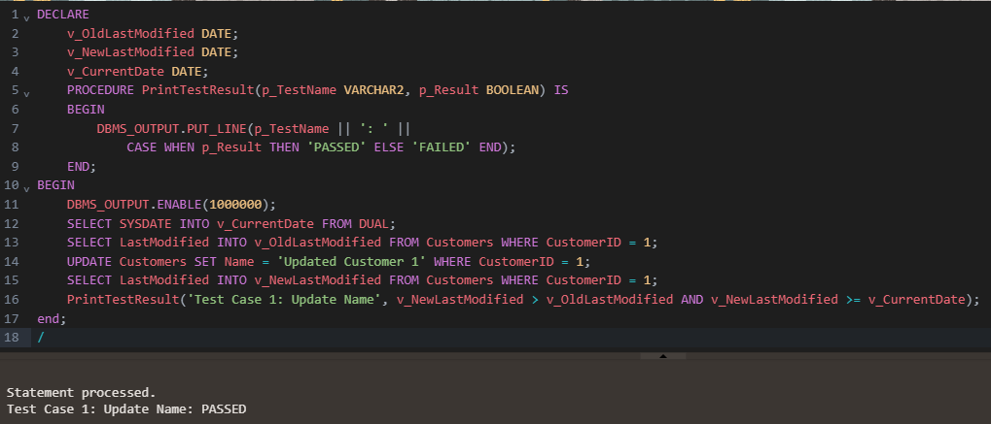

Q2.

CREATE SEQUENCE AuditLog_seq

START WITH 1

INCREMENT BY 1;

CREATE TABLE AuditLog (

LogID NUMBER PRIMARY KEY,

TransactionID NUMBER,

AccountID NUMBER,

TransactionDate DATE,

Amount NUMBER,

TransactionType VARCHAR2(10),

LogDate DATE

);

CREATE OR REPLACE TRIGGER LogTransaction

AFTER INSERT ON Transactions

FOR EACH ROW

BEGIN

INSERT INTO AuditLog (LogID, TransactionID, AccountID, TransactionDate, Amount, TransactionType, LogDate)

VALUES (

AuditLog_seq.NEXTVAL,

:NEW.TransactionID,

:NEW.AccountID,

:NEW.TransactionDate,

:NEW.Amount,

:NEW.TransactionType,

SYSDATE

);

END;

/

*Output:*

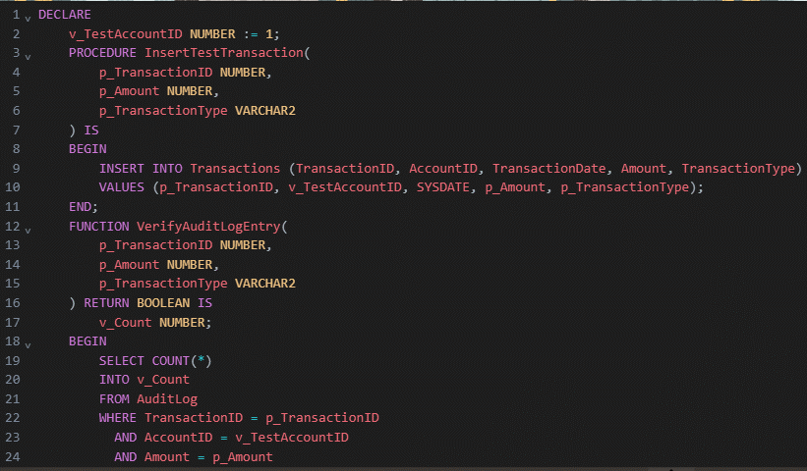

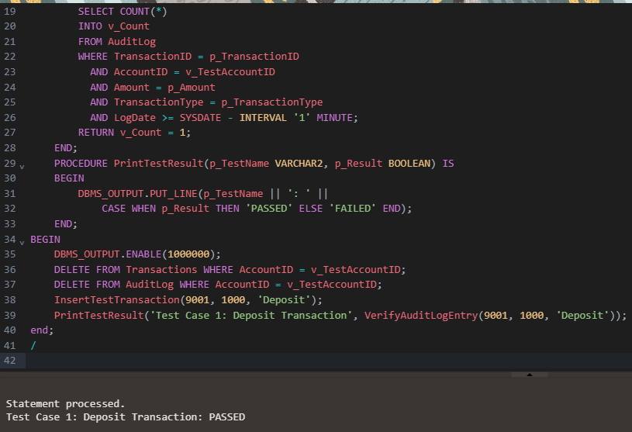

Q3.

CREATE OR REPLACE TRIGGER CheckTransactionRules

BEFORE INSERT ON Transactions

FOR EACH ROW

DECLARE

v_balance NUMBER;

BEGIN

-- Get the current balance of the account

SELECT Balance INTO v_balance FROM Accounts WHERE AccountID = :NEW.AccountID;

-- Check if the transaction is a deposit

IF :NEW.TransactionType = 'Deposit' THEN

IF :NEW.Amount <= 0 THEN

RAISE_APPLICATION_ERROR(-20001, 'Deposit amount must be positive.');

END IF;

-- Check if the transaction is a withdrawal

ELSIF :NEW.TransactionType = 'Withdrawal' THEN

IF :NEW.Amount > v_balance THEN

RAISE_APPLICATION_ERROR(-20002, 'Withdrawal amount exceeds the current balance.');

END IF;

END IF;

END;

/

*Output:*

